**PROG10082 Object Oriented Programming 1 – JAVA**

**Assignment 3**

**Author: Amir Hosein Khanmohammadi**

**Student ID: 991646689**

**Instructor: Muhammad Shafique**

**Date: October 27, 2022**

**Problem** *(Numeric string manipulations)*

Develop a Java application that

1. Takes a string of any length consisting of numeric digits only

2. Validates the input string consists of only digits

3. Takes the five right-most digits of the input string and converts to their equivalent decimal number

4. Converts the decimal number to its equivalent binary number

**Example**

Input string: “7891100123”

Valid input and 5- right most digits 00123

Equivalent

Decimal number: 123

Binary number: 01111011

**Requirements**

The application should have the following features:

1. Continue asking the user ‘Do you want to convert a numeric string to equivalent numbers?”. If the user’s response is “Yes” then the application continues, and the program terminates when the user’s response is “No”

* 1. 2. The program a. prompts the user for input string of any length.
  2. b. Validates that the input string consists of only decimal digits
  3. c. For a valid string, takes the 5 right-most digits of the string
  4. d. converts the substring consisting of the right-most 5-digits, to its equivalent decimal number
  5. e. converts the decimal number to its equivalent binary number.
  6. 3. Formatted output of the application should look like

Input string: xxxxxxxxxx

5 Right-most digits: ddddd

Equivalent

Decimal number: ddddd

Binary number: 0011010….

**Solution:**

**Solution**

1. **Analysis**

Inputs: inputs are answered for the “Do you want to convert a numeric string to equivalent numbers?” question that should be “yes” or “Yes” for continuing the program and if you want to end the program just need to type anything except “yes”, or “Yes”, getting a string from the user without any limitation length, and at the end after converting again asking the same question “Do you want to convert a numeric string to equivalent numbers?” this time if you want you can say “yes” for continue and give another string or just write anything and end the program. All of them are string values. The string that the user inputs for converting the 5 last digits cannot consist of any letter, just numbers accepted. And The number of user inputs cannot be less than 5 digits.

Output: The output is the result of the conversion of the 5 rightmost digits that the user inputs to a binary number.

The input asked from the user is all in string. I also checked if the input entered some letters or is less than 5 digits. I put the checking in “while” because I want to check until the user inputs a correct value greater or equal to 5 and not consisting of any letters.

In the end, I print the result of the conversion.

1. **Algorithm**
2. First, the user should decide if he wants to continue the program by answering the question “Do you want to convert a numeric string to equivalent numbers?”. If yes should enter “yes” if not just type anything except “yes”, and “Yes”. Then, get a string of any length consisting of numeric digits only and the program takes a string value from the user.
3. The string should be checked not to consist of any letters, and it should check that the length of the string is greater or equal to 5. If it has letters inside the string, or it is less than 5, The program alerts the user with the error and ask for entering a new string.
4. After getting a right string, the program extracts the 5 rightmost digits from the input string and convert it to integer and then convert integer to binary number. The conversion from string to integer is written in a method called “”. The conversion from integer to binary is written in a method called “”.

D) Output the result of converting decimal number to binary number.

/*

* Assignment 3 (Numeric string manipulations)

* instructor: Muhammad Shafique

* Author: Amir Hosein Khanmohammadi

* student number: 991646689

* Date: October 27 , 2022

*

* This application takes a string of any length consisting of numeric digits

* only, then validates the input string consisting of only digits, then

* takes the five right-most digits of the input string and converts them to

* their equivalent decimal number, and finally converts the decimal number

* to its equivalent binary number

*/

1. **Source code**

import java.util.Scanner;

public class Assignment3DecimalToBinary {

private static boolean checkDigit(String s) {

int len = s.length();

for (int i=0;i<len;i++)

if (s.charAt(i) < '0' || s.charAt(i) > '9') {

return false;

}

return true;

}

private static String decimalToBinary(int d) {

String binary="";// bin[]=new int[100];

int i = 0;

while(d > 0){

int temp = d%2;

if (temp==1)

binary="1".concat(binary);

else

binary="0".concat(binary);

i++;

d = d/2;

}

return binary;

}

private static int convertStringToNumber(String numStr) {

char ch[] = numStr.toCharArray();

int sum = 0;

//get ascii value for zero

//ascii = a character encoding standard for electronic communication

int zeroAscii = (int)'0';

for (char c:ch) {

int tmpAscii = (int)c;

sum = (sum*10)+(tmpAscii-zeroAscii);

}

return sum;

}

public static void main(String[] args) {

// for my debuging

// boolean a = checkDigit("67h8");

// System.out.println(a);

// int temp = convertStringToNumber("001234");

// System.out.println(temp);

Scanner sc = new Scanner(System.***in***);

String answer = "Yes";

do {

System.***out***.println("Do you want to convert a numeric string to equivalent numbers? ");

answer = sc.next();

if (!answer.toLowerCase().contentEquals("yes"))

break;

Scanner inputString = new Scanner(System.***in***);

System.***out***.print("Input string: ");

String userInput = inputString.next();

//check userInput is string

boolean check = *checkDigit*(userInput);

int len=userInput.length();

if (!check || len<5)

System.***out***.println("Wrong Input Please Enter Digits ONLY and more than 5 digits");

else {

String fiveLastInput = userInput.substring(len-5, len);

int fiveLastInputInt = *convertStringToNumber*(fiveLastInput);

System.***out***.println("5 Right-most digits: " +fiveLastInput);

System.***out***.println("Equivalent");

String binary = *decimalToBinary*(fiveLastInputInt);

System.***out***.printf("Decimal number: %d%n", fiveLastInputInt);

System.***out***.printf("Binary number: %s%n", binary);

}

} while(answer.toLowerCase().contentEquals("yes"));

System.***out***.println("Thank you for using my application!");

}

}

**Test cases specification:**

1. Sample run for test case 1

Do you want to convert a numeric string to equivalent numbers?

yes

Input string: 765567389108763

5 Right-most digits: 08763

Equivalent

Decimal number: 8763

Binary number: 10001000111011

Do you want to convert a numeric string to equivalent numbers?

YES

Input string: 33645359208654635

5 Right-most digits: 54635

Equivalent

Decimal number: 54635

Binary number: 1101010101101011

Do you want to convert a numeric string to equivalent numbers?

yES

Input string: 74654686300011

5 Right-most digits: 00011

Equivalent

Decimal number: 11

Binary number: 1011

Do you want to convert a numeric string to equivalent numbers?

No

Thank you for using my application!

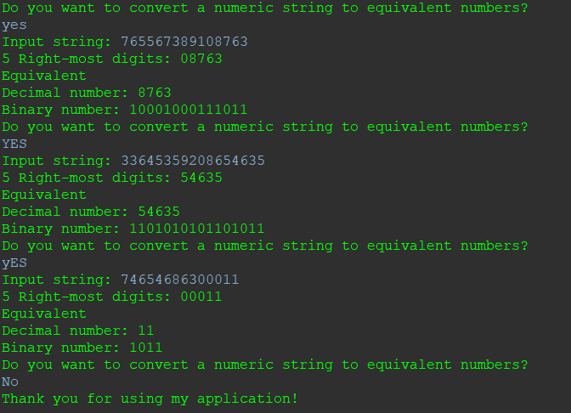

1. Sample run for test case 2

Do you want to convert a numeric string to equivalent numbers?

YES

Input string: aMiu347642935dbhfw4947364

Wrong Input Please Enter Digits ONLY and more than 5 digits

Do you want to convert a numeric string to equivalent numbers?

yes

Input string: 85

Wrong Input Please Enter Digits ONLY and more than 5 digits

Do you want to convert a numeric string to equivalent numbers?

YeS

Input string: 123855748392858585

5 Right-most digits: 58585

Equivalent

Decimal number: 58585

Binary number: 1110010011011001

Do you want to convert a numeric string to equivalent numbers?

no

Thank you for using my application!

1. Sample run for test case 3

Do you want to convert a numeric string to equivalent numbers?

yes

Input string: 7891100123

5 Right-most digits: 00123

Equivalent

Decimal number: 123

Binary number: 1111011

Do you want to convert a numeric string to equivalent numbers?

yes

Input string: 09124527914

5 Right-most digits: 27914

Equivalent

Decimal number: 27914

Binary number: 110110100001010

Do you want to convert a numeric string to equivalent numbers?

yeS

Input string: 0483764625819053305568

5 Right-most digits: 05568

Equivalent

Decimal number: 5568

Binary number: 1010111000000

Do you want to convert a numeric string to equivalent numbers?

no

Thank you for using my application!

1. Sample run for test case 4

Do you want to convert a numeric string to equivalent numbers?

yes

Input string: sheridancollege.ca907355277485

Wrong Input Please Enter Digits ONLY and more than 5 digits

Do you want to convert a numeric string to equivalent numbers?

yes

Input string: 202

Wrong Input Please Enter Digits ONLY and more than 5 digits

Do you want to convert a numeric string to equivalent numbers?

yes

Input string: 66883777266241060

5 Right-most digits: 41060

Equivalent

Decimal number: 41060

Binary number: 1010000001100100

Do you want to convert a numeric string to equivalent numbers?

NO

Thank you for using my application!

1. Sample run for test case 5

Do you want to convert a numeric string to equivalent numbers?

no

Thank you for using my application!

